Looking into Laudato Si’:
a thematic index
Sheila Thomas and Clare Enright

The Papal encyclical "Laudato Si'" is the focus of the annual Season of Creation, which the Cambridge Justice & Peace Group marks each year with an activity. We appreciate that the scope of the encyclical is far larger than the topics generally addressed in 'Care for Our Common Home', which tends to focus on the natural world. So we set out to
identify, and demonstrate as clearly as possible, both the wide range of subjects included by Pope Francis in what he has termed "Integral Ecology", and their inter-relationships.

We picked out key words and phrases through-out the text, supplementing the terms provided in the index, noting the paragraphs relevant to each and grouping these themes where most closely related. The result is presented in the following tables and figures which use colour to group the related themes.
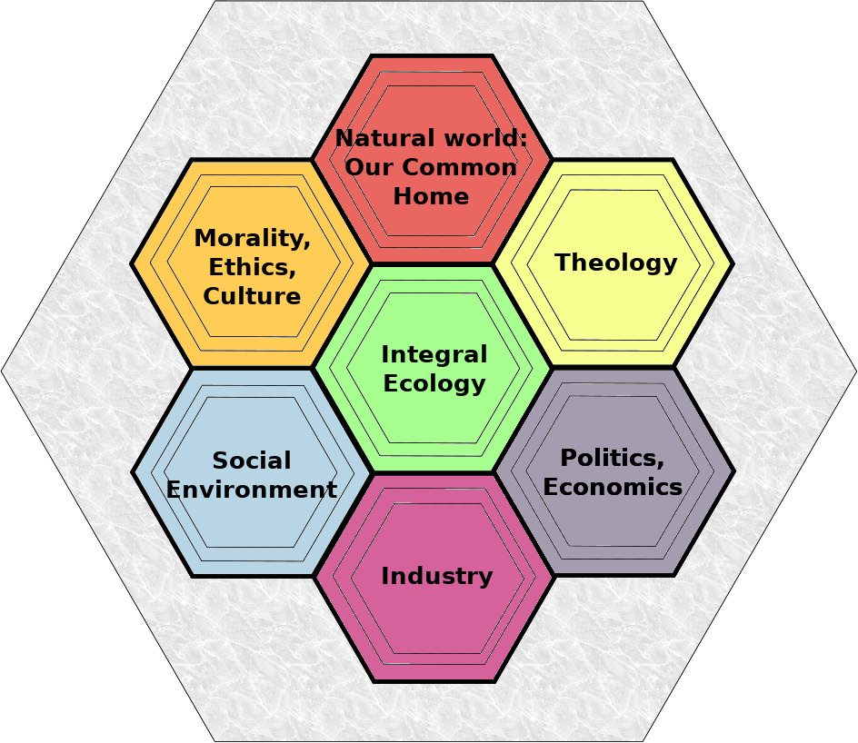

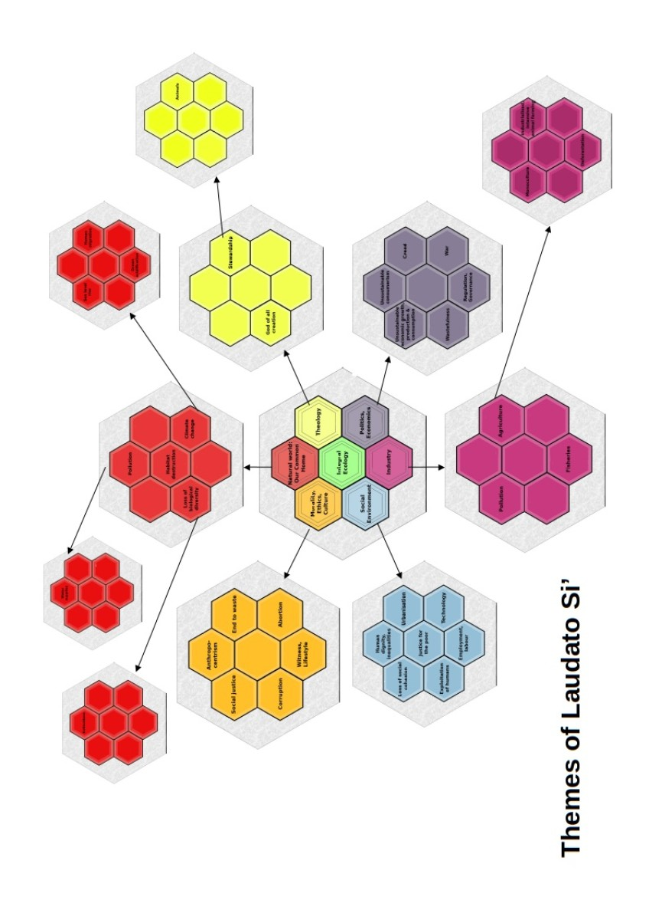
Major themes of Laudato Si’

Integral ecology | 137,138,139,140,141,142,143,144,145,146,147,148,149,150,151,152,153,154,155,156,157,158,159,160,161,162,230
The Natural World / Our Common Home | 2,11,13,14,25,48,53,61,110,122,163,164,  201,231
Morality, Ethics, Culture | 8,105,106,110,114,121,131,132,135,136,  143,144,145,146,199,204,207,208,209,211,213,225,229,233,236,237,238
Theology | 1,62,63,64,65,66,67,68,69,70,71,72,73,74,  75,76,77,78,79,80,81,82,83,84,85,86,87,88,89,90,91,92,93,94,95,96,97,98,99,100,199,200,201,202,203,204,205,206,216,217,241,242,245
Social environment | 43,47,82,91,93,112,113,114,142,148,153
Economics and Politics | 54,56,57,109,128,129,141,178,179,180,  181,182,183,186,187,189,190,194,195,196,197,198,231
Industry

Secondary Themes The Natural World / Our Common Home

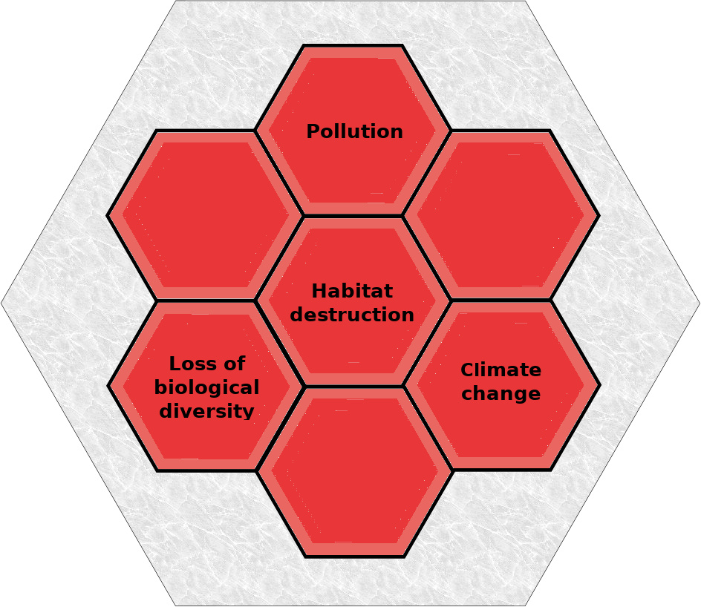

Climate change | 23,24,25,26,52,167,169,170,171,172,175,181
Loss of biological diversity | 24,32,33,35,37,38,39,42,91,123,167,168,169,190,195
Habitat destruction | 23,36,39,41,51
Pollution | 20,21,24,29,41,44,47,48,50,51,59,111,153,165,167,170,172,175,177,180,184,195,  246

Minor themes of Natural World

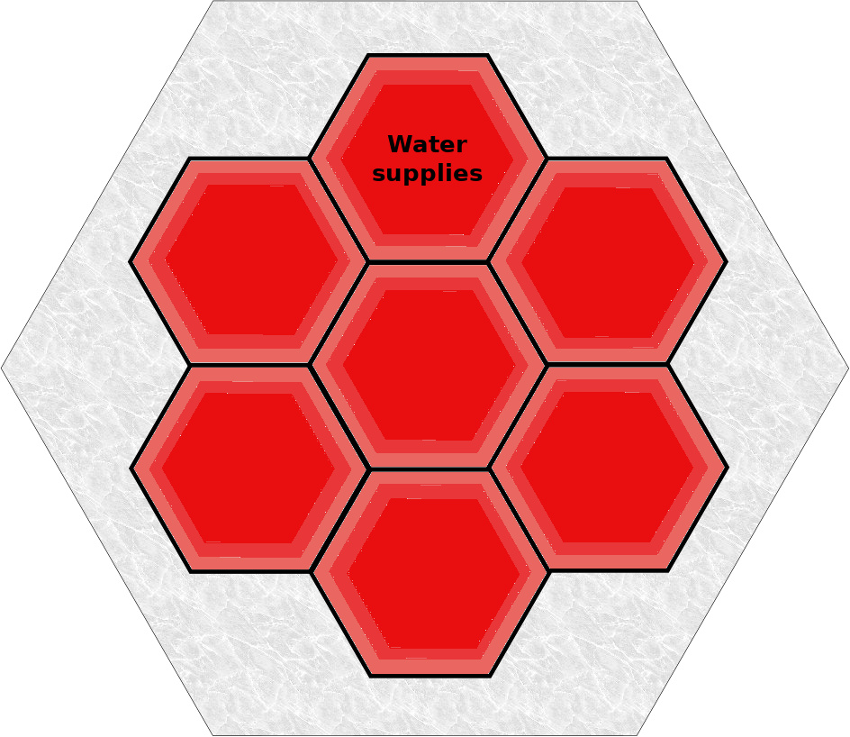
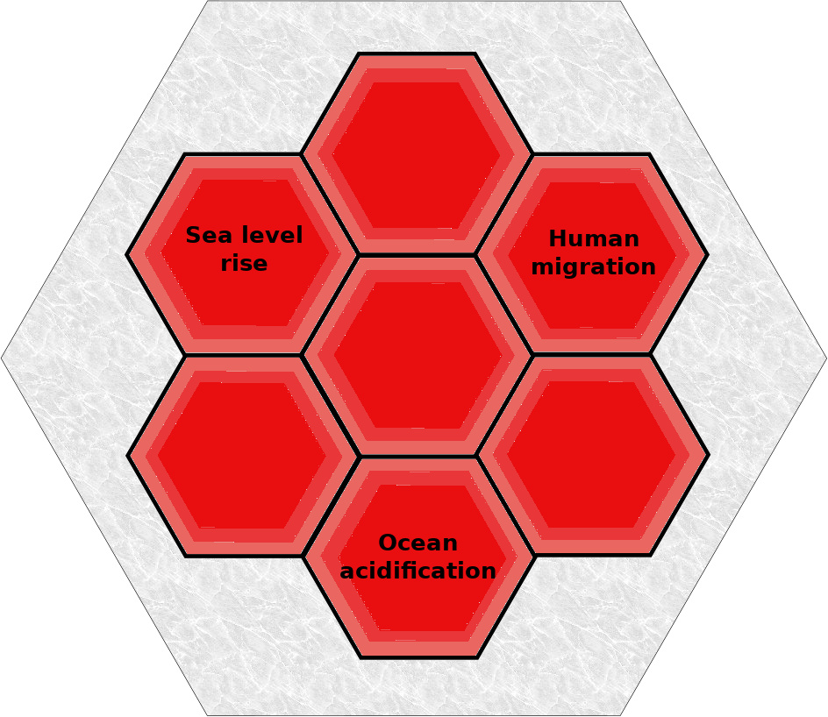

Climate change | Human migration | 25
 | Sea level rise | 23,24,28
 | Ocean acidification | 24
Pollution | Water supplies | 2,8,20,24,28,29,30,31,35,37,40,  44,48,72,84,87,140,164,185,  211,234,235
Loss of biological diversity | Extinctions | 24,34,35,42,89

Secondary Themes of Morality, Ethics, Culture

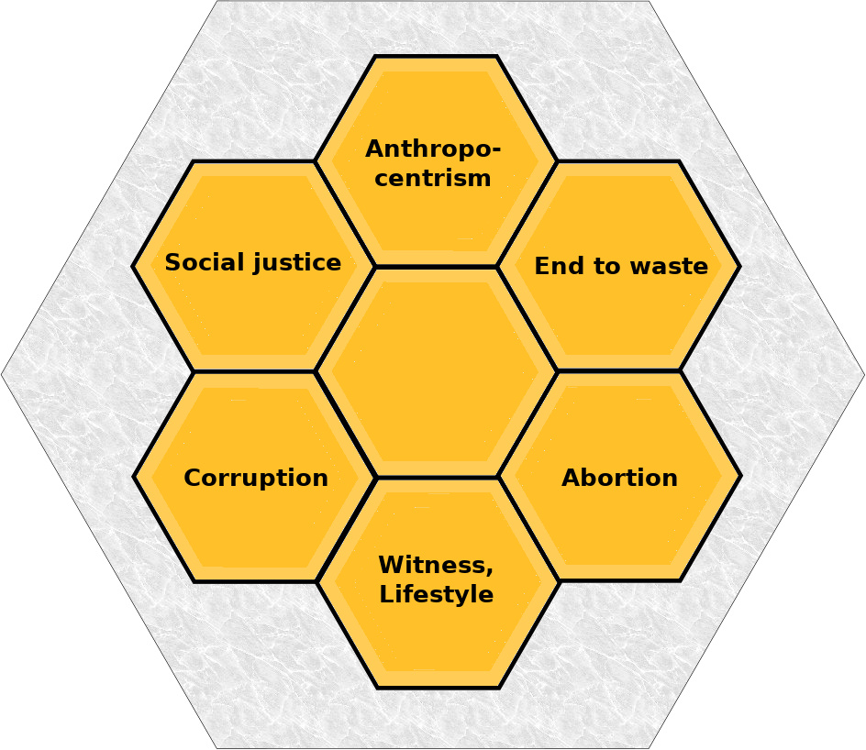

Anthropocentrism | 68,69,115,116,118,119,122
Social justice | 45,70,185
End to waste | 27,123
Corruption | 22,182
Abortion | 117,120,136
Witness,Lifestyle | 58,212,214,218,223,224,227,228

Secondary Themes of Theology

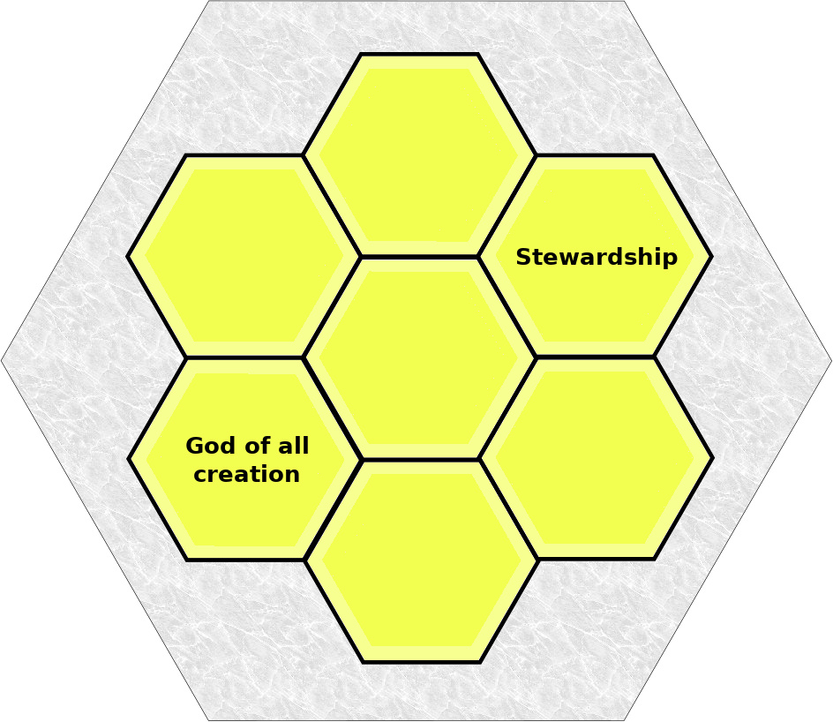

Stewardship | 68,78,116,119,220,244
God of all Creation | 12,65,66,76,80,84,85,86,87,88,89,220,221,  234,235

Minor theme of Theology

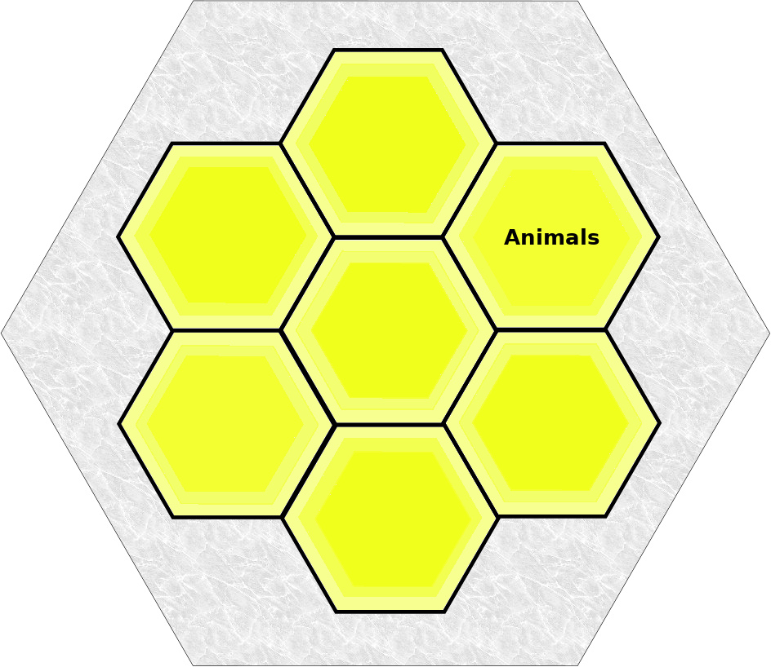

Stewardship | Animals | 68,69,77,82,83,86,87,92,96,  100,123,130,140,239,243,  244

Secondary Themes of Social Environment

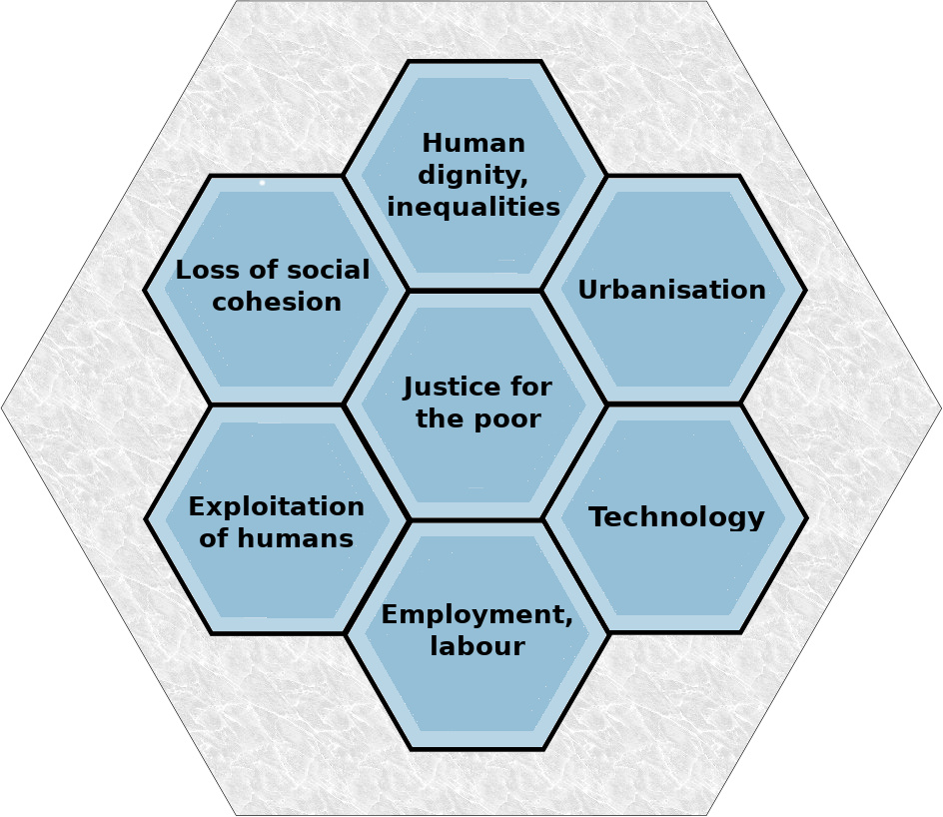

Justice for the poor | 29,30,94,95,158,162,172,196
Human dignity / inequalities | 48,49,50,51,52,56,65,81,90,92,93,119,128,  130,136,193,205
Loss of social cohesion | 46
Urbanisation | 44
Exploitation of humans | 123
Technology | 9,16,20,54,60,101,102,103,104,105,106,  107,108,109,110,112,113,114,131,136,165,  172
Employment / labour | 124,125,126,127,128,129

Secondary Themes of Politics and Economics
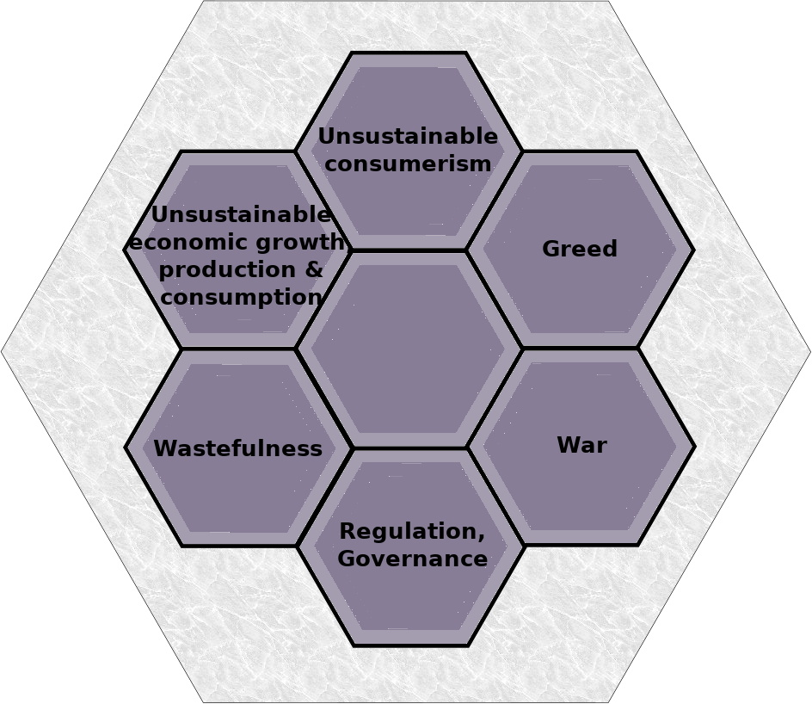

Unsustainable consumerism | 34,50,178,180,184,191,192,  203,204,206,209,210,215,  219,222,226,232
Unsustainable economic growth/production & consumption | 9,54,55,109,123,141,161,  193,194,221
Greed | 9
Wastefulness | 180,16,22,43,123
War | 57
Regulation, Governance | 142,166,173,174,175,176,177,179,231

Secondary Themes of Industry

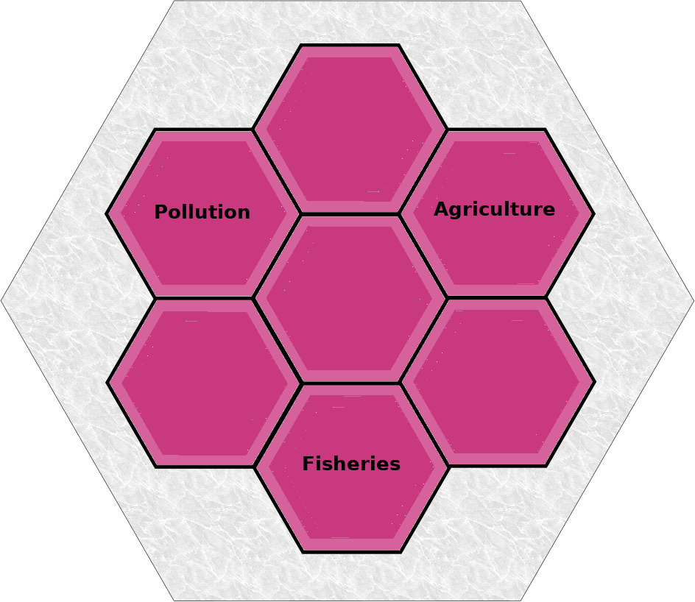

Pollution | 20,21,24,29,41,44,47,48,50,51,59,111,153,165,  167,170,172,175,177,180,184,195,246
Agriculture | 133
Fisheries | 40

Minor themes of Industry

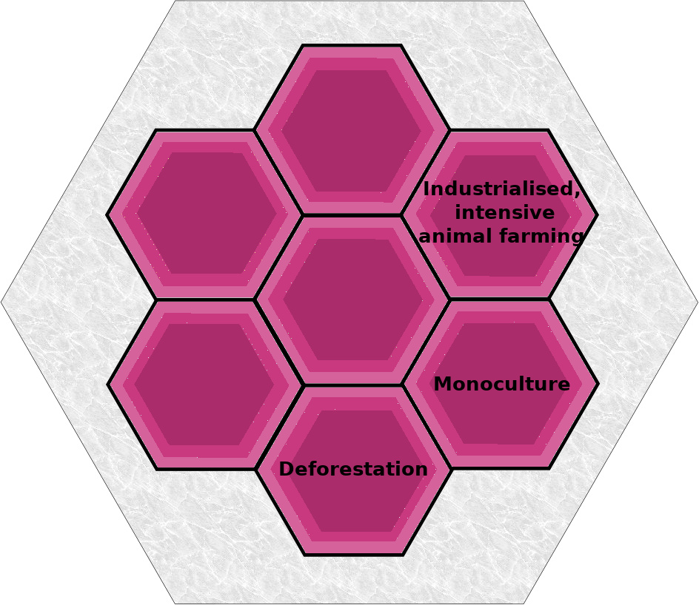

Agriculture | Industrialised, intensive animal farming | 134
 | Monoculture | 39
 | Deforestation | 23,38,41,51

